**Notes_Attachment_Sub_Job - Technical Specifications**

|  |  |  |  |
| --- | --- | --- | --- |
|  | Prepared By | Reviewed By | Approved By |
| Name | Himanshu Srivastava |  |  |
| Signature | Himanshu Srivastava |  |  |
| Date | 01/18/2019 |  |  |

Revision History

|  |  |  |  |  |
| --- | --- | --- | --- | --- |
| Date | Version | Description | Author | Reviewer |
| 01/18/2019 | 0.1 | Initial Version Created | Himanshu Srivastava |  |
|  |  |  |  |  |
|  |  |  |  |  |

Contents

1. Overview 3

1.1. Purpose 3

1.2. Functional Description 3

1.3. Related Application Requirements 3

1.4. Key Considerations 3

1.5. Related Documents References 4

1.6. Acronyms and Terms 4

2. Technical Description 5

2.1. Processing Logic 5

2.2. Inbound/Outbound NAS 6

2.3. Selection Criteria 6

2.4. BRC Dependency 6

2.5. Mapping Sheet 6

2.6. Process Flow 6

2.7. Restart Processing 7

2.8. Acknowledgement/Reconciliation Processing 7

2.9. Error Processing 7

2.10. Logs Location:- 8

2.11. Architectural Mechanism/ Business Module 8

2.12. Application Interfaces 8

2.13. Security 8

# Overview

## Purpose

This document details out the technical implementation of the Notes Attachment Talend ETL Sub job. It covers all the technical details for the above mentioned process.

## Functional Description

Notes Attachment is a reusable sub job in ETL which can be plugged in to any job to create notes and attachments. Developer needs to pass only required parameters and add new BRC configurations for new style IDs. This will save us a lot of dev and QA efforts.

## Related Application Requirements

|  |  |
| --- | --- |
|  |  |
|  | N/A |
|  |  |
|  |  |
|  |  |
|  |  |

## Key Considerations

|  |  |  |
| --- | --- | --- |
| Impact (New, Enhancement) | Object/Module/Program/File Type | Object/Module/Program/File Name |
| N/A |  |  |
|  |  |  |
|  |  |  |

## Related Documents References

This document use references from the following artifacts.

<https://github.optum.com/UHOneFacets/Payment_AP_REAP_Inbound_Facets_ETL>

## Acronyms and Terms

The following list of acronyms and terms are used within this document:

| Acronym / Term | Description |
| --- | --- |
|  |  |

# Technical Description

## Processing Logic

Notes Attachment is a reusable sub job in ETL which can be plugged in to any job to create notes and attachments. The jobs have been used under AP/REAP inbound process. It a parameterized job and would be required following parameters:

|  |  |  |
| --- | --- | --- |
| Parameters | Description | Values Used for AP/REAP |
| ProgId | Key Fields based on which attachment is created.  Such as SBSB_ID, CLCL_ID etc. For AP/REAP CKPY_REF_ID was the key field. | (String)globalMap.get("ORIG_PAY_NUM") |
| AtndText | Attachment Note Text | globalMap.get("PAY_METHOD")+" NO = "+globalMap.get("PAY_ASND_PAY_NUM")+" and AP "+globalMap.get("PAY_METHOD")+" DATE ="+globalMap.get("REORIGN_DT") |
| AttbId | Attribute ID/ Table ID, For AP/REAP that table was CKPY. | CKPY |
| AttbType | Attachment Table Type, Attachment tables are either Source or Destination. Source tables are those that have an Attachment Source ID and destination tables have an Attachment Destination ID | S |
| ATXR_DESC | Attachment Description, A free-form description of this attachment. For example, if you are adding a note, you could type a brief summary of the contents of the note. | globalMap.get("PAY_METHOD")+" PROCESSED with "+globalMap.get("PAY_METHOD")+" NO and AP "+globalMap.get("PAY_METHOD")+" DATE" |
| AtsyId | BRC ID** | AP_NOTES |

**In order to create the job reusable BRC has been created to pass the attachment queries dynamically.

AP_NOTES – This crosswalk BRC has been used for AP/REP notes attachment, user can create similar or reuse the same BRC in case the attachment is for CKPY tables only. The BRC has 3 parts

1. Notes Style ID - The attachment style which was used to create this note.
2. Query 1 – Query to retrieve the Attachment source ID from source table(CKPY table in case of AP/REAP)
3. Query 2 – Query to update the Attachment source ID into source table(CKPY table in case of AP/REAP)

|  |  |  |  |  |
| --- | --- | --- | --- | --- |
| [**Instance**](javascript:__doPostBack('ctl00$MainContent$GridValues','Sort$InstanceID')) | [**SourceValue**](javascript:__doPostBack('ctl00$MainContent$GridValues','Sort$SourceValue')) | [**TargetValue**](javascript:__doPostBack('ctl00$MainContent$GridValues','Sort$TargetValue')) | [**TargetType**](javascript:__doPostBack('ctl00$MainContent$GridValues','Sort$TargetType')) | [**TargetDesc**](javascript:__doPostBack('ctl00$MainContent$GridValues','Sort$TargetDesc')) |
| FSG | ATSY_ID | ATN0 | Notes Style ID | Notes Style ID |
| FSG | QUERY1 | SELECT @ldtAtxrSourceId = ATXR_SOURCE_ID FROM CMC_CKPY_PAYEE_SUM WHERE CKPY_REF_ID = @lchProgId | CKPY Query | CKPY Query |
| FSG | QUERY2 | UPDATE CMC_CKPY_PAYEE_SUM SET ATXR_SOURCE_ID = @ldtAtxrSourceId WHERE CKPY_REF_ID = @lchProgId AND ATXR_SOURCE_ID = '01/01/1753' | CKPY Update | CKPY Update |

## Inbound/Outbound NAS

## Selection Criteria

N/A

## BRC Dependency

* + AP_NOTES

## Mapping Sheet

* **N/A**

## Process Flow

***Talend Master Jobs for AP/REAP*:**

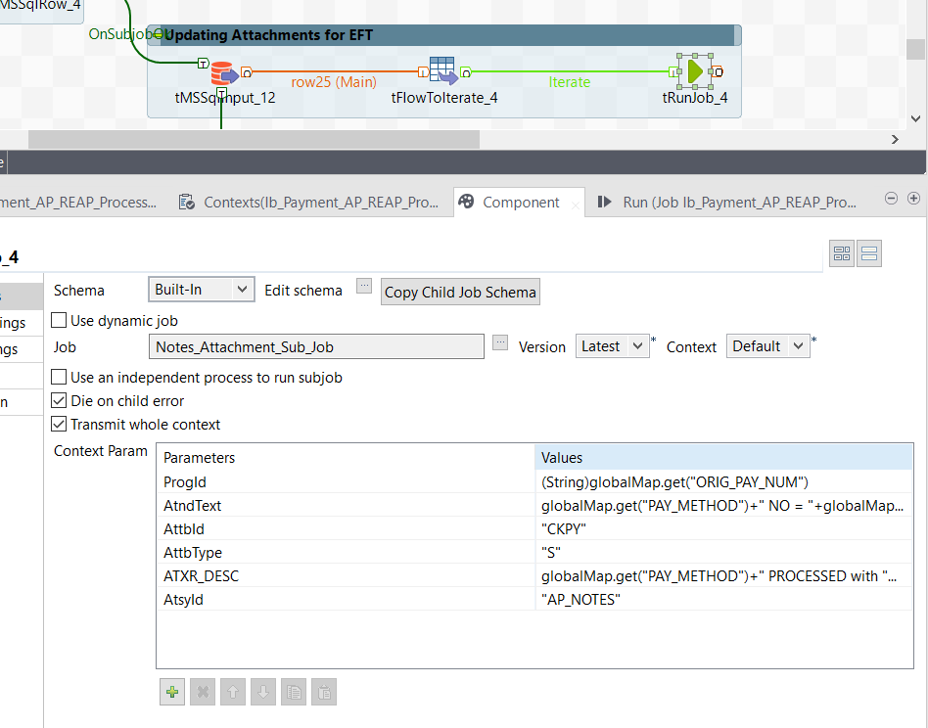

## Restart Processing

* + 1. Program Restart: - N/A
    2. Batch Restart - Talend batch can be restarted manually from initial point.

## Acknowledgement/Reconciliation Processing

N/A

## Error Processing

N/A

## Logs Location:-

## Architectural Mechanism/ Business Module

Please refer Section 1.5

## Application Interfaces

**Talend Jobs:**

* Ib_Payment_AP_REAP_Process
* Notes_Attachment_Sub_Job

## Security

N/A